Undergraduate Research Opportunities
Opportunity 1: Are you an undergraduate interested in research experience and credit in crop genomics and fungal dynamics?

An undergraduate research position is available in the Devos Lab in the Departments of Plant Biology & Crop and Soil Sciences for the summer and Fall of 2017.

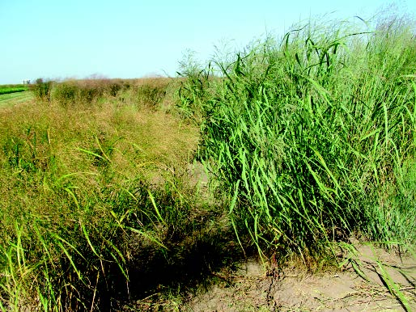
We currently are investigating the genetics of cold tolerance and mycorrhizal fungi interactions in switchgrass, an important native bioenergy crop. We use experiments in the field, greenhouse, growth chambers and the lab to identify critical genes and examine how their expression affects these and other crucial traits.

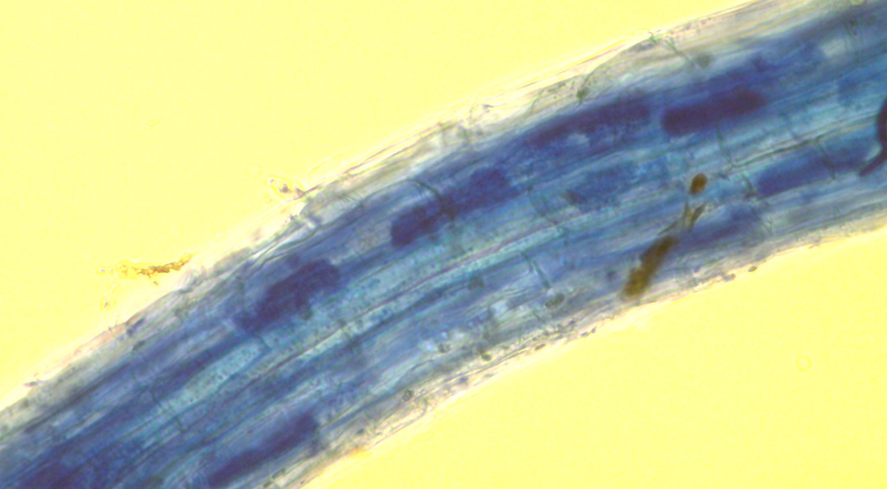
Students in first 3 years of their undergraduate degree are welcome to apply. Research credit is available through PBIO/GENE/BIOL or similar courses in your major. PBIO majors and minors are eligible for $500 “Plant Biology Undergraduate Independent Research Support Awards” to facilitate independent research.

To apply, please send the following information to Tom Pendergast at thpiv@uga.edu :

- A resume or CV listing courses taken, GPA, research experience, etc.
- A brief (1/2 page) statement describing your interests in science, academic and career goals, and what you hope to gain from research experience.

Opportunity 2:
Undergraduate research positions are available in the Devos lab for Summer/Fall 2017 (Research credit for PBIO/GENE/BIOL departments.)

Project Description:

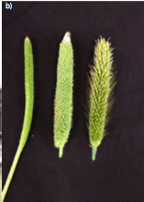
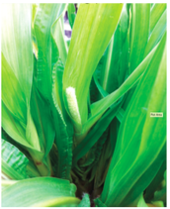
Plant height is of interest to farmers and plant breeders because significant yield losses occur when tall plants fall due to heavy winds or rain. Br1 and d4 are both loci that affect plant height in pearl millet. Plants that are homozygous for d4 are dwarfs, have extremely curly leaves, and reduced panicle size when compared to tall plants. However d4 dwarfs that carry the Br1 have bristled panicles and are semi dwarfs with normal panicle morphology. The goals of this project are to determine the genes responsible for these traits, and to gain insight into what plant processes are causing these changes in height.

There are 2 phases to the project:
Phase I: Fine mapping BR1
Skills developed during this phase:
- Basic understanding of genetic mapping
- Genetic marker development (and different types of markers and methods)
- DNA extraction
- Polymerase chain reaction (PCR)
- Gel electrophoresis
- Sanger sequencing
- RNA extraction
- qPCR analysis
Phase II: Validation of Current Candidate Gene for d4
Skills developed during this phase (in addition to those developed in phase I):
- Experimental design
- Transformation of model organism Arabidopsis thaliana
- Designing overexpression constructs
- Hydroponic cultivation of pearl millet
PBIO majors and minors are eligible for $500 “Plant Biology Undergraduate Independent Research Support Awards” to facilitate independent research.
- Please send résumés (including courses taken, GPA and research experience) to acjohn84@uga.edu
- Include a description of career interests and goals
- Devos lab website: http://research.franklin.uga.edu/devoslab/

